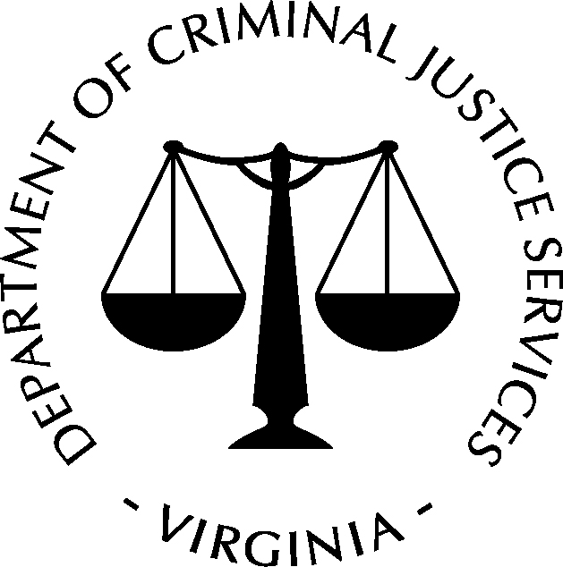
COMMONWEALTH OF VIRGINIA
Department of Criminal Justice Services
PO Box 1300 • Richmond, VA 23218
Phone: (804) 786-4700 • Fax: (804) 786-6344 www.dcjs.virginia.gov

Special Conservator of the Peace – APPLICATION CHECKLIST
- Submit the Special Conservator of the Peace Registration Application or apply online at www.dcjs.virginia.gov/online.
- Proof of liability: Certificate of Professional Law Enforcement Liability Insurance (minimum $500,000.00). Please ensure DCJS is listed as a certificate holder.
- For Initial Applicants Only:
- Drug and Alcohol Testing:
  - Contact Erica Ambrose at 1-800-732-3784 or by email at EAmbrose@fssolutions.com. When contacting Erica Ambrose, notify the receptionist that you are with the Special Conservator of the Peace program.
  - To locate the Labcorp site nearest you, please visit www.labcorp.com and go to the Patient Service Center location. The cost for testing is $44.00. Payment methods are in the form of a money order, certified check, or credit card.
- Background investigation completed by a police department, sheriff's office, or the Virginia State Police.
- Application to Courts:
Note: A temporary registration will be issued after all of the above eligibility criteria have been met. This letter should be taken to the circuit court to petition for a SCOP appointment by the employing agency. This temporary registration does not guarantee appointment and does not authorize you to engage in providing SCOP services without a court appointment order.
  - All applications and orders for appointment are required to be submitted on forms developed by the Office of the Executive Secretary of the Supreme Court of Virginia.
  - The application for appointment can be accessed at the Virginia’s Judicial System website: www.courts.state.va.us/forms/circuit/civil.html.
  - Once the circuit court signs the order, you must return copies of both the (#1) Application and
(#2) Appointment Order to DCJS in order to receive your registration document.
- For those seeking a New Appointment or Reappointment:
- Background investigation completed by a police department, sheriff's office, or the Virginia State Police.
- Application to Courts:
  - All applications and orders for appointment are required to be submitted on forms developed by the Office of the Executive Secretary of the Supreme Court of Virginia.
  - The application for appointment can be accessed at the Virginia’s Judicial System website: www.courts.state.va.us/forms/circuit/civil.html
  - Once the circuit court signs the order, you must return copies of both the (#1) Application and
(#2) Appointment Order to DCJS in order to receive your registration document.
- For Renewals Only: If the current registration is expired, you have 60 days from the expiration date to submit a non-refundable reinstatement fee of $30.00 and meet all of the renewal requirements. If the 60 day reinstatement period has passed, you cannot use this form, as you are no longer eligible for renewal and you must complete the initial registration process. You cannot work during a reinstatement period.

